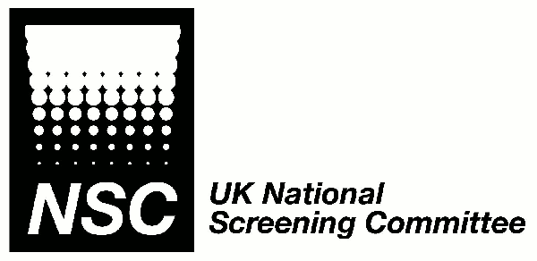
UK National Screening Committee
Antenatal screening for Asymptomatic Bacteriuria

Consultation comments pro-forma

Name: |  |  |  | Email address:
Organisation (if appropriate):
Role:
Do you consent to your name being published on the UK NSC website alongside your response?

Yes No

Section and / or page number |  | Text or issue to which comments relate |  |  | Comment  Please use a new row for each comment and add extra rows as required.
Please return to the Evidence Team at screening.evidence@nhs.net by 23rd January 2017

